WellnessHub – Personalized Wellness Management Program

System Proposal

CP3540 – Applied ASD Project
2026 07 16
Table of Contents

- Executive Summary 1
- Proposed Features and Objectives 2
- Requirements 3
- Architecture and Technology Stack 4
- Deployment
- The Team
Executive Summary

People are constantly bombarded with messages about health and wellness throughout broadcast, streaming, and social media. They’re told to do one thing, not do another, do these things but not those things, purchase this product or service, and here’s the latest shocking study finding that should lead a person to completely upend their life and habits. On top of this, they are often pressured to tell the entire world about every last activity in which they engage, making every personal effort into a competition. It can be overwhelming for someone who just wants to feel a bit better in their body and mind, and would like a predictable, consistent source of information, suggestions, and support.

WellnessHub aims to be an app for people who want gentle guidance and support through their personal wellness journey. The app will provide users with suggestions for meals, simple physical activities, and mindfulness based on data they provide, and allow them to track things like their water intake, physical activity, and emotional state, all accessible through a dashboard. New content can be added using a simple CMS utilizing Markdown, with access granted to vetted professionals in the appropriate fields.

The app will be built on well-tested, well-supported Web development technologies, and once in production will be hosted in the cloud. As the app will host user-provided, personally-identifiable information related to their health, security and privacy are paramount concerns.
Proposed Features and Objectives

Meal Suggestions | Suggest simple physical activities | Suggests mindfulness based on provided data | Tracks water intake and emotional state
Allows user to browse recipes by cuisine | Tracks users exercise | Provides guidance for yoga and stretching | Easily accessible through the dashboard

Requirements

Architecture and Technology Stack

WellnessHub will use a simple three-tier web architecture. Users will interact with the React frontend, which will send secure REST API requests to the Node.js and Express.js backend. The backend will manage user accounts, wellness recommendations, tracking features, and content. MongoDB will store user profiles, recipes, articles, mood entries, water records, exercise records, and progress information. JWT will be used to authenticate users and protect private routes.
Architecture Diagram
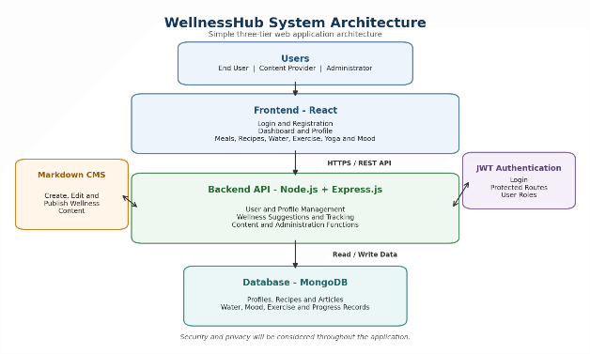
Figure 1. WellnessHub system architecture.

Component Diagram
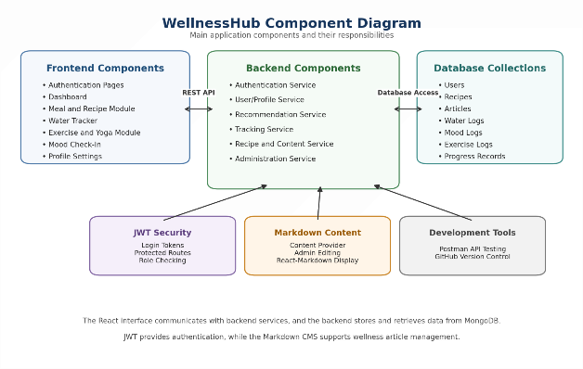
Figure 2. Main WellnessHub software components.
Technology Stack
Component | Technology
Frontend | React, React-Markdown
Backend | Node.js, Express.js
Database | MongoDB
Authentication | JWT
API Testing | Postman
Version Control | GitHub

Proposed User Interface

The following UI mockups show simple example screens for the WellnessHub application. These designs illustrate how the main user pages may look in the final system.

Login Screen

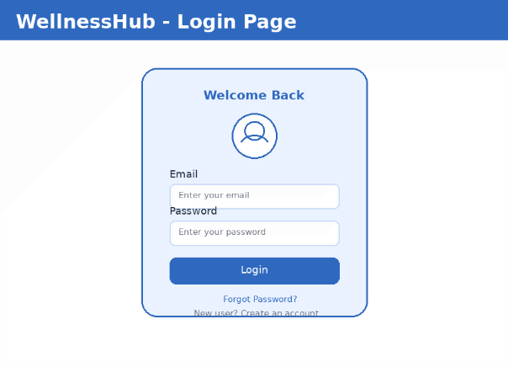
Figure 3. Sample login screen for user sign-in and account access.

Dashboard Screen
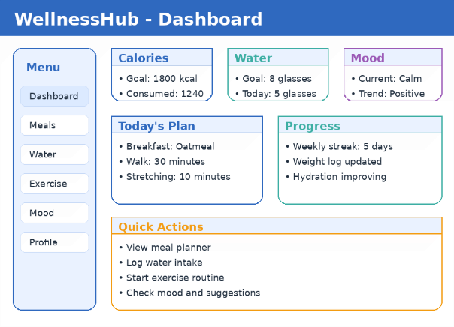
Figure 4. Sample dashboard showing wellness summary and quick actions.

Meal Planner Screen
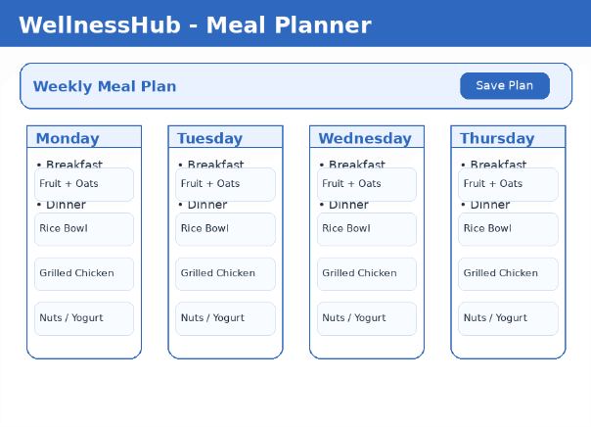
Figure 5. Sample weekly meal planner interface for users.

Deployment

The Team

WellnessHub comes from a team of new programmers eager to deliver an application that works for its users and their needs, rather than exploiting them.

Anumol Thomas – Title
Anumol is....

Josh Ennis – Title
Josh...

Tyler Bown – Title
Tyler...

Mark Phoenix – Title
Mark spent twenty-five years in media, with longstanding side interests in computers and systems administration. To this, he brings new skills in Python, JavaScript, React, microservice development, containerization and deployment, and cloud infrastructure. He enjoys making things work and fixing things that don’t. He wants to create applications centered on end users and their needs.

